DO NOW- Read the quote and answer the 2 questions below.

Mr. President,

I confess that there are several parts of this constitution which I do not at present approve, but I am not sure I shall never approve them: For having lived long, I have experienced many instances of being obliged by better information or fuller consideration, to change opinions even on important subjects, which I once thought right, but found to be otherwise. It is therefore that the older I grow, the more apt I am to doubt my own judgment, and to pay more respect to the judgment of others. Most men indeed as well as most sects in religion, think themselves in possession of all truth, and that where ever others differ from them it is so far error.

Benjamin Franklin, 1787

- What was Benjamin Franklin’s initial reaction to the document?

- Ultimately, does Benjamin Franklin support or oppose the new Constitution? Why do you think this? Use specific textual evidence to support your answer.

April 16, 1787

I would propose next that in addition to the present Federal powers, the national government should be armed with positive and complete authority in all cases which require uniformity; such as the regulation of trade, including the right of taxing both imports and exports, the fixing the terms of naturalization (becoming a citizen), etc.

- James Madison, Federalist, to George Washington

1. Who wrote this statement? Who was he writing to?

2. What type of powers does the author believe the national government should “be armed with positive and complete authority”?

3. Does the author support or oppose the Constitution?

October 24, 1787

After such a declaration, what security does the Constitution of several States afford the liberty of the press and other invaluable personal rights, not provided for by the new plan? Does not his sweeping clause subject everything to the control of Congress?
In the Articles of Confederation, the second article declared that each state retained its sovereignty, freedom and independence, and every power, jurisdiction and right which is not by this Constitution expressly delegated to the United States in this Congress.

-George Bryan, Anti-Federalist

1. Who wrote this article? When was it originally printed?

2. What rights were not provided for in the new plan [the Constitution]?

3. If these rights were taken away, who would control of the people?

4. What did the states keep under the Articles of Confederation?

5. Does the author support or oppose the Constitution?

Federalists Anti-Federalists
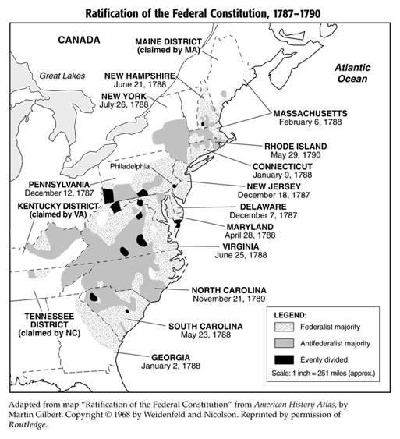
1. In which states were most of the Federalists located?

2. In which states were most of the Anti-Federalists located?

3. What were the first three states to ratify the Constitution? Were these states considered Federalists or Anti-Federalists?

4. What does location tell you about which political party an early American might be associated with?
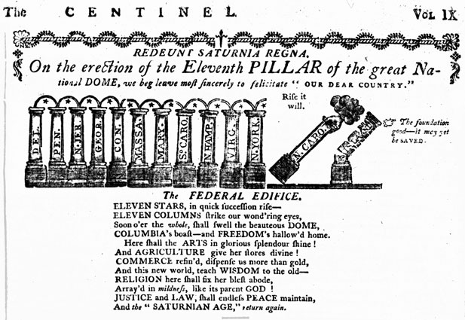

Massachusetts Newspaper- The Centinel

1. What do the pillars in the comic symbolize?

2. What is happening to the pillars and how does this represent the county?

3. Do you believe this newspaper is Federalist or Anti-Federalist? Why?

Melancton Smith, New York, Anti-Federalist, June 21, 1788

Representatives should be a true picture of the people. They should understand their circumstances and their troubles. Therefore, the number of representatives should be so large that both rich and poor people will choose to be representatives.

If the number of representatives is small, the position will be too competitive. Ordinary people will not attempt to run for office. A middle-class farmer will never be chosen. So, the government will fall into the hands of the few and the rich. This will be a government of oppression. The rich consider themselves above the common people, entitled to more respect. They believe they have the right to get anything they want.

- What problem does Melancton Smith have with a small number of representatives in Congress?

- Which class of people does he seem to favor and how can you tell?
- What is he afraid will happen if the opposing class of people run the government?

Alexander Hamilton, New York, Federalist, June 21, 1788

The Anti-Federalists seem to think that a pure democracy would be the perfect government. Experience has shown that this idea is false. The ancient democracies of Greece were characterized by tyranny and run by mobs. The Anti-Federalists also argue that a large representation is necessary to understand the interests of the people. This is not true. Why can’t someone understand fifty people as well as he understands twenty people? The new constitution does not make a rich man more eligible for an elected office than a poor person. I also think it’s dangerous to assume that men become more wicked as they gain wealth and education. Look at all the people in a community, the rich and the poor, the educated and the ignorant. Which group has higher moral standards? Both groups engage in immoral or wicked behavior. But it would seem to me that the behavior of the wealthy is less wicked and
sinful.

1. Why does Alexander Hamilton not want a Democracy?
2. What is Hamilton’s opinion on the relationship between wealth and wickedness?
3. What type of government do you think Hamilton is suggesting instead of a direct democracy?
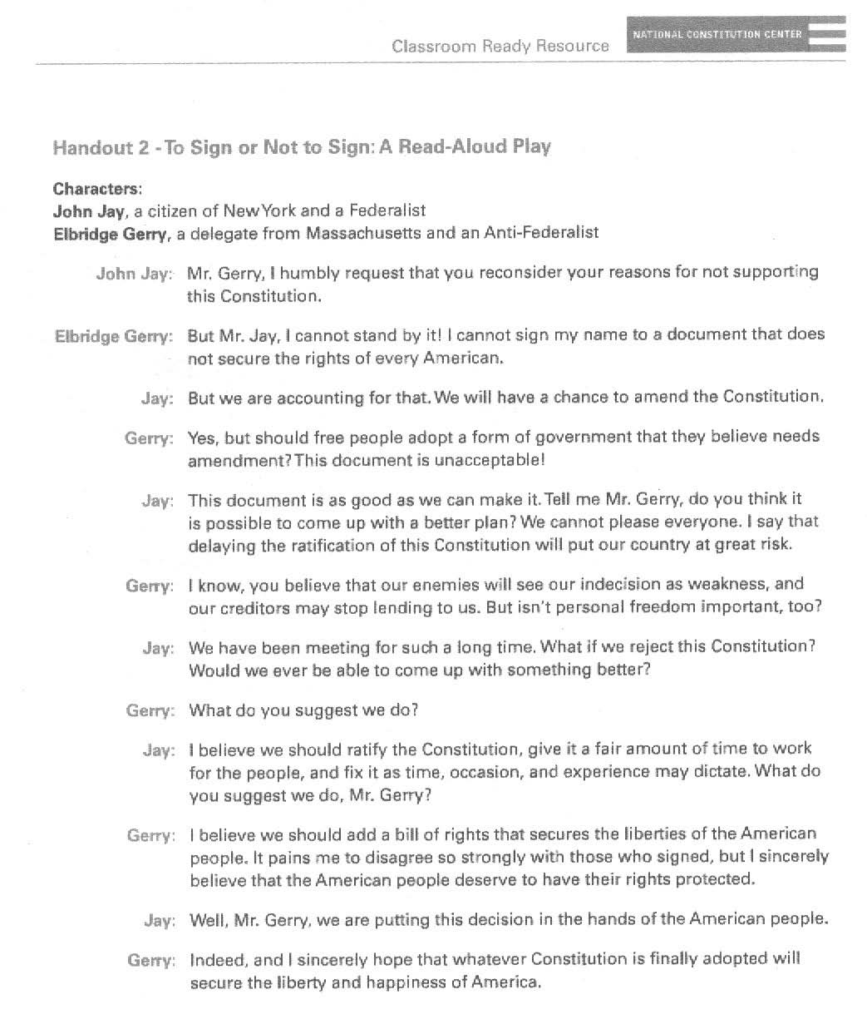

1. What is the strongest reason John Jay gave for signing the Constitution?
2. What is the strongest reason Elbridge Gerry gave for NOT signing the Constitution?
3. Which delegate do you agree with? Why?

“And here I would make this question of those worthy characters who composed a part of the Constitutional Convention. I am sure they were aware of the need of forming a stronger centralized, national government, instead of a confederation. That this is a strong central government is clear; and the danger of such a government is, to my mind, very striking. I have the highest respect for those gentlemen; but, sir, let me just say, what right did they have to say, ‘We, the people’? My political curiosity, independent of my care for public welfare (or general well-being of the average citizen), leads me to ask, who authorized them to speak the language of, ‘We, the people’, instead of, ‘We, the states’ ?”

-Patrick Henry, Virginia, Anti-Federalist, June 1788

- When was the document written and why is the date important?

- What is the author’s point of view? Regarding the Constitution? Why do you think so?

It is evident that one national government could tax imports further than practical to separate States or partial confederacies and at much less expense. Until now, I believe these taxes in any State have not averaged more than 3%. In France they are estimated to be 15% and in Britain the proportion is still greater.
Nothing would hinder this country from tripling the present amount. Alcohol alone, under federal regulation, might furnish considerable revenue. Based on the importation into this State (New York), the whole quantity imported into the United States may be estimated at four million gallons. A shilling per gallon would produce 200,000 pounds (unit of currency). Alcohol would easily bear this rate of duty. However, if the tax diminished the consumption of alcohol, such a consequence is equally favorable, favorable to agriculture, the economy, the morals, and the health of society. There is, perhaps, nothing so much a subject of national extravagance as these drinks.
-Federalist Paper No. 12., November 27, 1787.

1. How do the Federalists believe the United States should raise money to cover its debt? What evidence is used to support this?

2. What is one positive and one negative of following this plan? Be descriptive!

“To the People of North Carolina,” Anti-Federalist position, The Wilmington Centinel, NC, 21 April 1788
Remember that most of you have taken an oath to support the present [state] government and with the state constitution! By that constitution all the power of the government is vested in the general assembly, the governor, and the chief judges. It is now proposed to you to adopt a new system which gives every essential part of that power, that is, all legislative, executive, judicial, military, and financial authority to a Congress who will sit at or near Philadelphia, 4 or 500 miles from you.  This is sabotaging our government and it should be opposed by every citizen because:
- There is no bill of rights in it.
- Although different religions are allowed to set in Congress, yet there is no liberty given to the people to perform religious worship according to the dictates of their consciences.
- There is nothing said about the people being allowed the freedoms of speech and the liberty of the press.
- It divides Congress into three branches, as President, Senate, and a House of Representatives, which will be a great clog to business and a hindrance to the making of laws with expedition and dispatch [with order and speed].
- It augments [increases] the members of Congress and makes the government more expensive.
- It deprives the people of the liberty of choosing their delegates to Congress annually, and of recalling them when they please.
- It almost annihilates the state governments, and deprives their legislation of the power of making their own laws.
- It makes no provision against the keeping a standing [permanent] army in a time of peace.
- It vests Congress with power to tax all the states, to send forth collectors, and enforce the payment of taxes by a standing army.
- It vests Congress with power to run the people into debt by borrowing money of foreign nations upon the credit of the United States, and it doth not oblige the members of that assembly to render any account of the expenditure of the same, if they shall see fit to secret it [keep the accounts secret].
- It deprives the inhabitants of each state of the power of choosing their superior and inferior judges.
Thus, my beloved friends, have I given you the foregoing hints that you may be upon your guard and ward off the impending danger. Keep the power in your own hands and let nothing be established that may deprive you of your liberties and make you unhappy.
1. Where is this document originally read?
2. Does the author support the U.S. Constitution? How can you tell?
3. What are 3 parts of the U.S. Constitution that he feels are missing and why does he want them included? Do they have to deal with politics? The economy? Society? Explain your reasoning.
Name the document:
___________________________________________________________________
___________________________________________________________________
___________________________________________________________________
___________________________________________________________________
___________________________________________________________________
___________________________________________________________________
___________________________________________________________________
___________________________________________________________________
___________________________________________________________________
___________________________________________________________________
___________________________________________________________________
___________________________________________________________________
___________________________________________________________________
___________________________________________________________________
___________________________________________________________________

Name the document:
___________________________________________________________________
___________________________________________________________________
___________________________________________________________________
___________________________________________________________________
___________________________________________________________________
___________________________________________________________________
___________________________________________________________________
___________________________________________________________________
___________________________________________________________________
___________________________________________________________________
___________________________________________________________________
___________________________________________________________________
___________________________________________________________________
___________________________________________________________________
___________________________________________________________________

